TUTORIAL FOR

ANOVA (one way)

IN R PROGRAM

Hypothesis: Two replications are different at P level less than 0.05

INPUT data

Save as .txt file as format below.



### Set directory for the input file

>setwd("D:/Tomato Lab/Phan Thi Ngan/Program tutorials/ANOVA")

### Load input file into R program

>data <- read.table ("anova.txt", header=T)

### Look at the data

>data

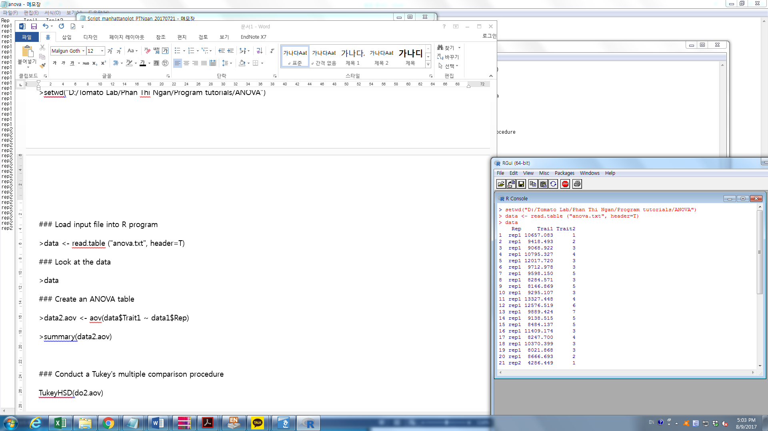

### Create an ANOVA table

If you want to compare between 2 replications of Trait1 you can type as below

>data2.aov <- aov(data$Trai1 ~ data$Rep)

>summary(data2.aov)

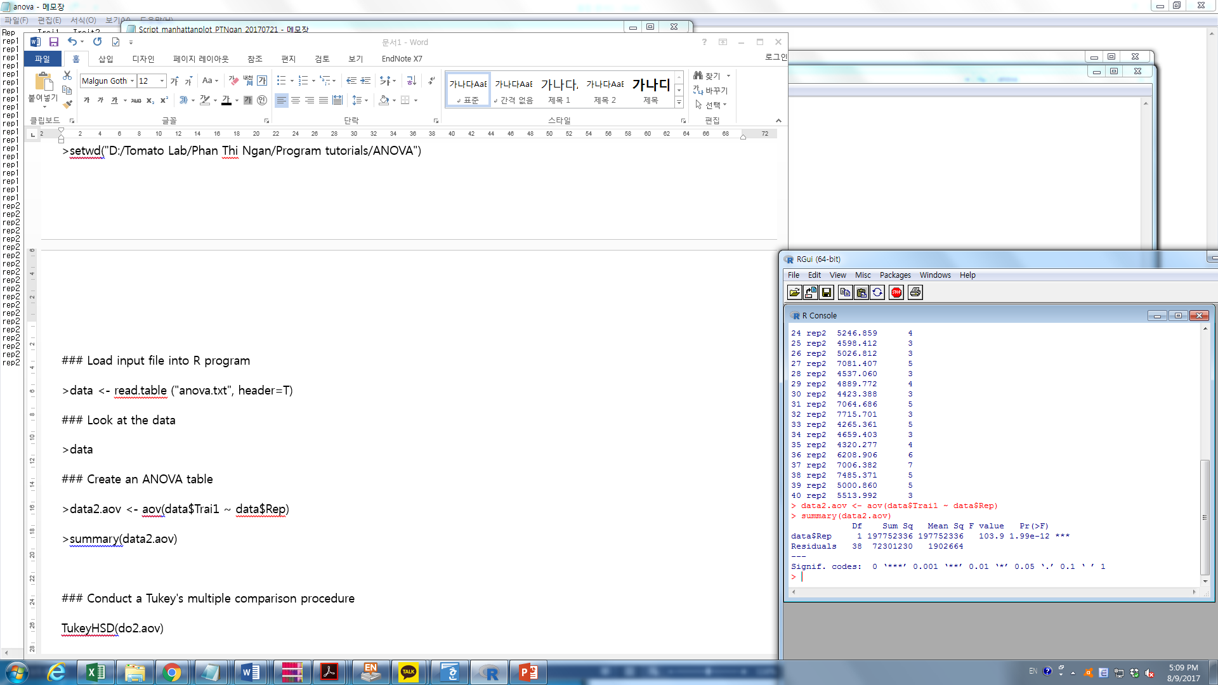

This result mean rep1 and rep2 is significant different at level P=0

If you want to continue with Trait2, then do similarly:

>data3.aov <- aov(data$Trait2 ~ data$Rep)

>summary(data3.aov)

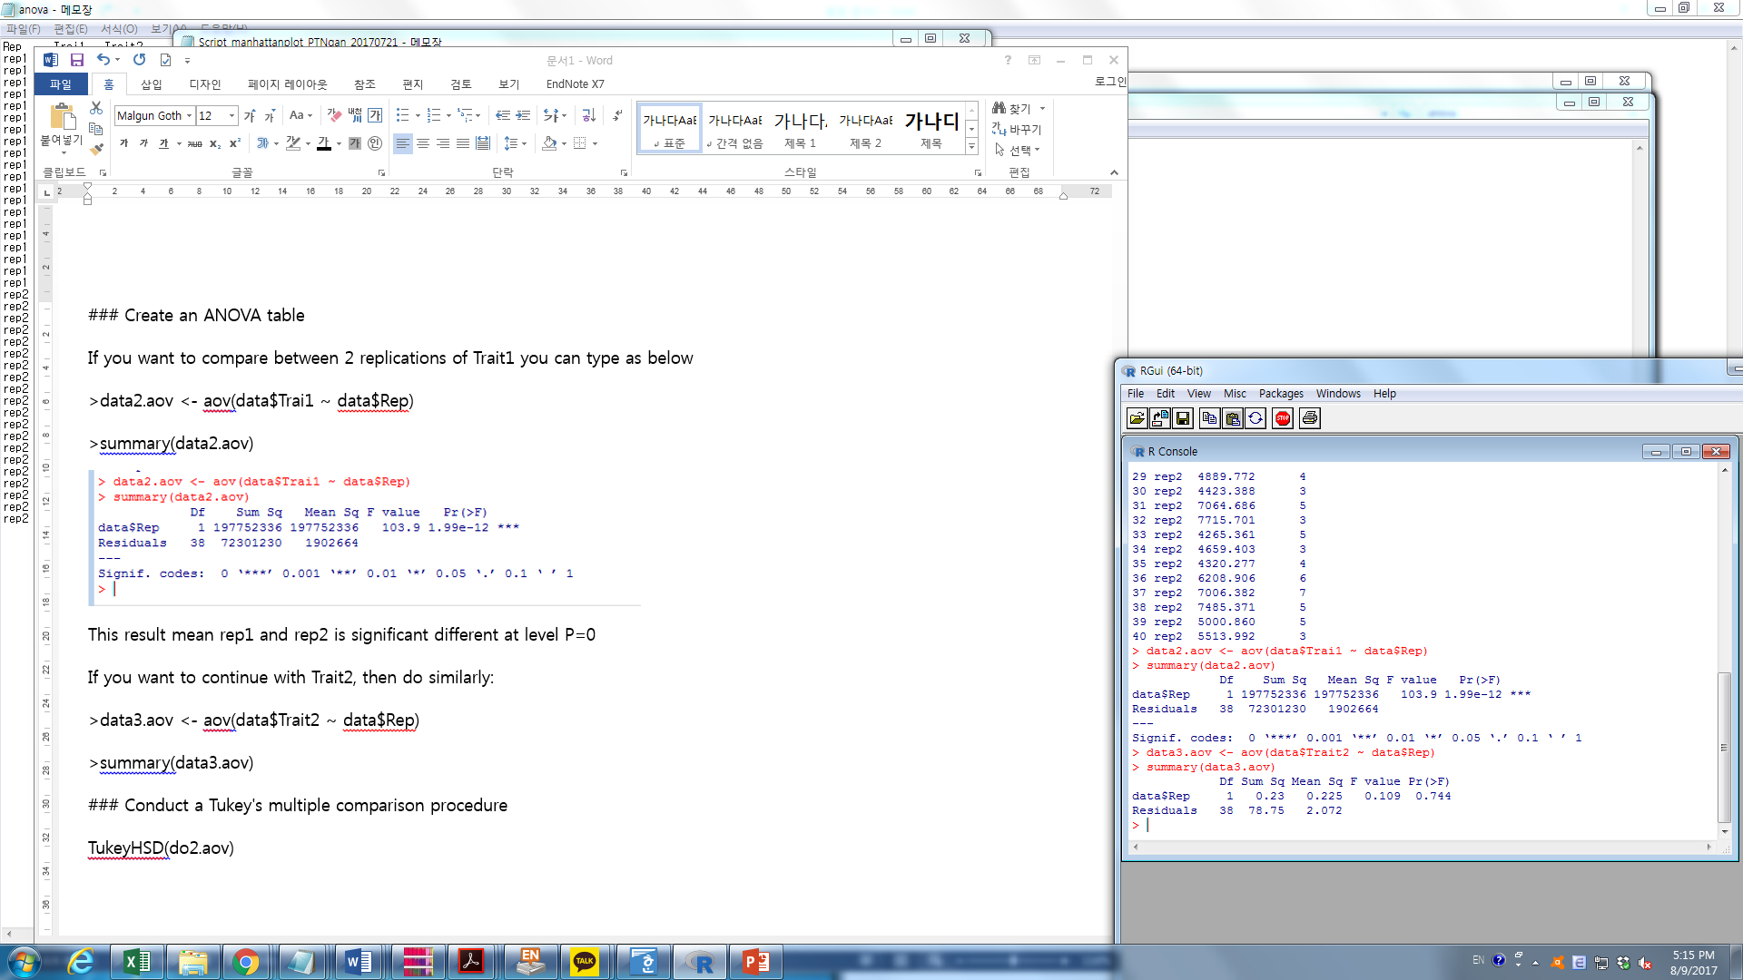

This result mean rep1 and rep2 of Trait2 is not different.

BESIDE ANOVA, you can test using Tukey’s multiple comparison

Conduct a Tukey's multiple comparison procedure

>TukeyHSD(data3.aov)

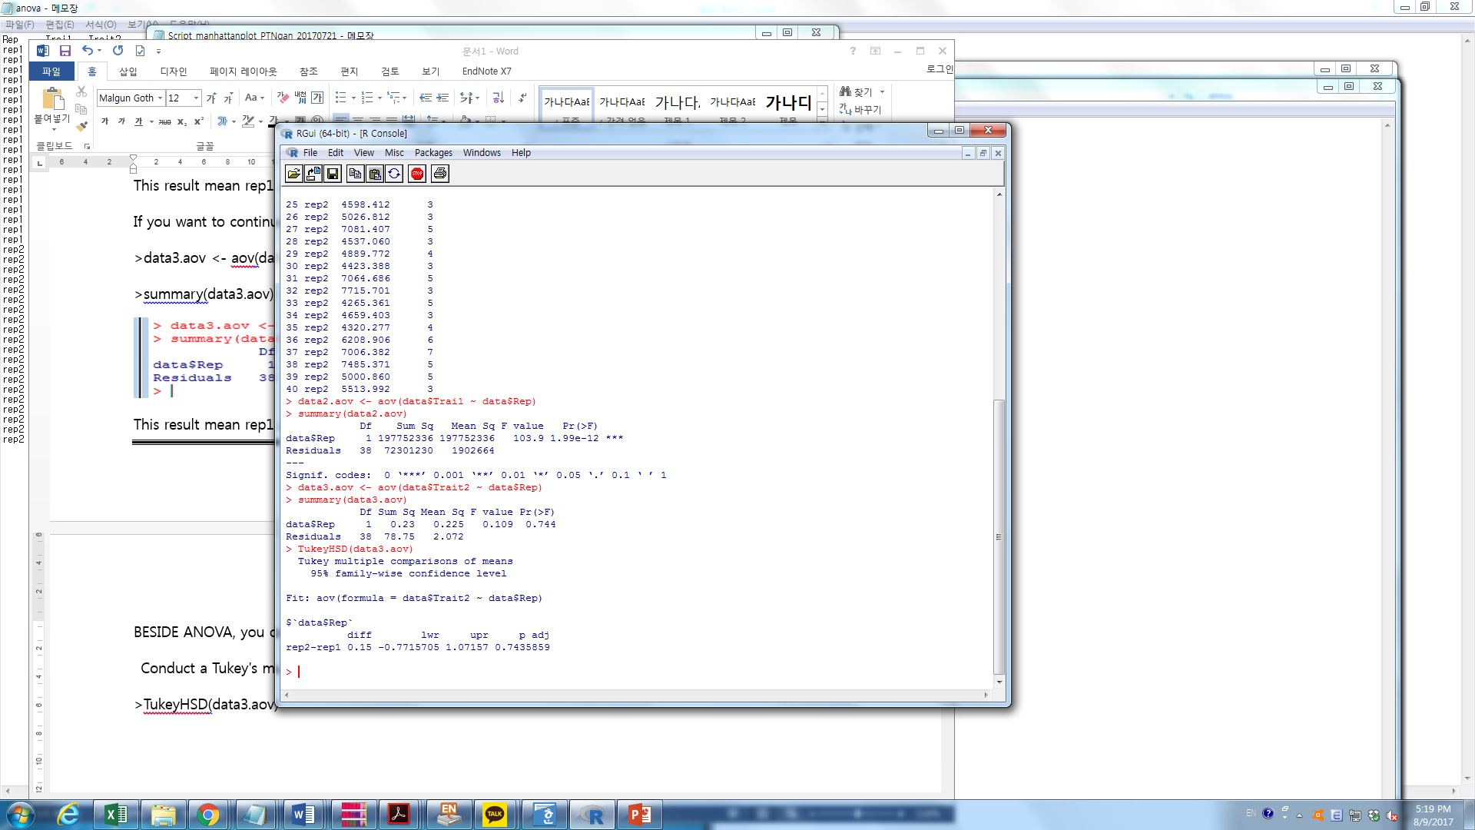

This method give similar P value with anova

-The end-